
Computer Vision
MCA-574
Case Study – 06
(Elements of Digital Image Processing System)
BY
HIMANSHU HEDA (24225013)
SUBMITTED TO
Dr. Preety Shoran
SCHOOL OF SCIENCES
2024-25

Case Study: Automatic Attendance System using Face Detection

1. Objective / Problem Statement
The primary objective of this case study is to understand the fundamental elements that constitute a Digital Image Processing (DIP) system by examining the practical application of an Automatic Attendance System (AAS) using Face Detection. The problem statement addresses the need for efficient, accurate, and automated attendance tracking in various environments (e.g., educational institutions, workplaces) that traditionally rely on manual, time-consuming, and error-prone methods. By dissecting the AAS, we aim to identify and explain the role of each core component of a DIP system, thereby elucidating its architecture and data flow, and illustrating these concepts with practical coding examples.

2. Concept Explanation (Relevant Theoretical Background)
Digital Image Processing (DIP) involves using computer algorithms to perform operations on a digital image. It is a subfield of signal processing and concerns itself with two main tasks: improving pictorial information for human interpretation and processing image data for storage, transmission, and representation for autonomous machine perception. A typical DIP system comprises several key elements that work in conjunction to achieve a desired outcome. These elements can generally be categorized as:
- Image Acquisition Sensor: The device responsible for capturing the raw visual data from the physical world and converting it into a digital format.
- Image Processing Unit (Processor): The hardware (e.g., CPU, GPU, specialized DSP) that executes the algorithms and computations required for image manipulation and analysis.
- Software / Algorithms: The set of instructions and mathematical models applied to the digital image data to perform tasks like enhancement, restoration, segmentation, feature extraction, and recognition.
- Output Module: The component responsible for presenting the processed information in a human-readable format or for transmitting it to another system for further action.
- Mass Storage: Devices for archiving images and other data.
- Image Display: Devices for viewing images.
- Hardcopy Device: For producing permanent copies.
- Network: For data transfer.
Face Detection, a specific application within DIP, is the task of identifying the presence and location of human faces in an image or video. It's often the first step in more complex face recognition systems. Algorithms like Haar cascades, Histogram of Oriented Gradients (HOG), and Convolutional Neural Networks (CNNs) are commonly employed for this purpose. Once faces are detected, features can be extracted and compared against a database for recognition.

3. Case Description / Scenario
Consider a university classroom where manual attendance is taken at the beginning of each lecture. This process often takes 5-10 minutes, disrupting the flow of the class and sometimes leading to inaccuracies due to proxy attendance or human error. To mitigate these issues, the university decides to implement an Automatic Attendance System (AAS) based on face detection.
In this scenario, a high-resolution camera is mounted at the entrance or front of the classroom, continuously monitoring the students. As students enter and settle down, the system automatically captures images or video frames. These visual data streams are then fed into a central processing unit. The system is pre-trained with a database of registered student faces. During operation, it detects faces in the live feed, compares them to the stored templates, identifies each student, and marks their attendance in a digital ledger. The faculty can then access this attendance record instantly via a dashboard.
Here's a conceptual illustration of the setup:
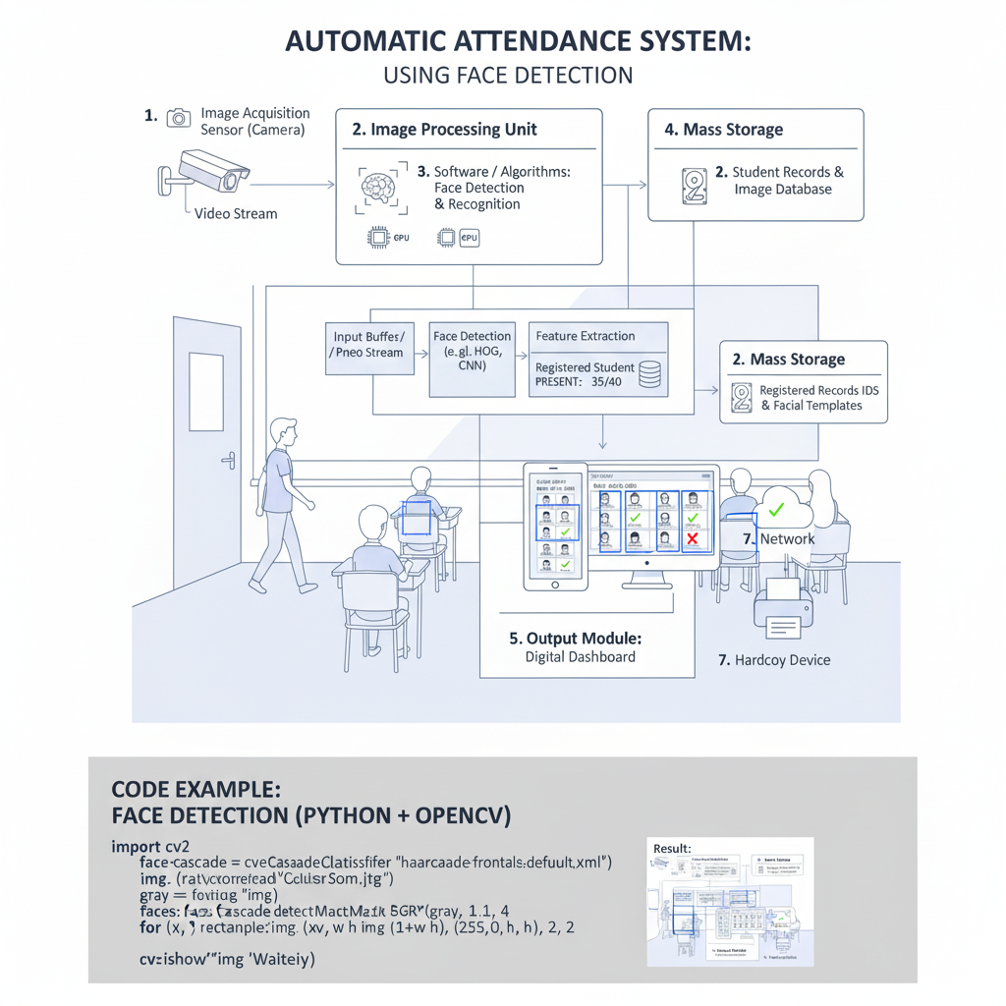

4. Analysis / Discussion (Connect Theory to the Selected Case)
Let's dissect the Automatic Attendance System (AAS) using the theoretical framework of Digital Image Processing system elements, illustrating key steps with Python coding examples where applicable.
- Image Acquisition Sensor:
  - Role: In our AAS, the high-resolution camera serves as the image acquisition sensor. It captures the raw visual information – the students' faces – from the real world. This analog optical signal is then converted into digital data (pixels).
  - Coding Perspective: In Python, using libraries like OpenCV, acquiring an image from a camera is straightforward.
import cv2

# Initialize the camera (0 for default webcam)
cap = cv2.VideoCapture(0)

if not cap.isOpened():
print("Error: Could not open video stream.")
else:
ret, frame = cap.read() # Read a frame
if ret:
cv2.imwrite("persons.jpg", frame) # Save the captured image
print("Image captured successfully!")
cap.release()
cv2.destroyAllWindows()
- Image Processing Unit (Processor):
- Role: The central processing unit (CPU) or a dedicated Graphics Processing Unit (GPU) provides the computational power. This hardware executes the complex mathematical operations involved in face detection and recognition. GPUs are crucial for accelerating deep learning models.
- Coding Perspective: While we don't explicitly 'code' the processor, the libraries we use (like OpenCV, TensorFlow, PyTorch) are optimized to leverage available processing power, often with backend configurations for GPUs.
import cv2

# Load the pre-trained Haar cascade for face detection
face_cascade = cv2.CascadeClassifier(cv2.data.haarcascades + 'haarcascade_frontalface_default.xml')

# Load an image (replace 'student_group.jpg' with your image)
img = cv2.imread('student_group.jpg')
if img is None:
print("Error: Could not load image.")
else:
gray = cv2.cvtColor(img, cv2.COLOR_BGR2GRAY) # Convert to grayscale for detection

# Detect faces in the image
faces = face_cascade.detectMultiScale(gray, scaleFactor=1.1, minNeighbors=5, minSize=(30, 30))

# Draw rectangles around the detected faces
for (x, y, w, h) in faces:
cv2.rectangle(img, (x, y), (x+w, y+h), (255, 0, 0), 2) # Blue rectangle

# Display the result
cv2.imshow('Detected Faces', img)
cv2.waitKey(0)
cv2.destroyAllWindows()
- Software / Algorithms:
- Role: This is the "brain" of the AAS, comprising various algorithms for image manipulation and analysis.
- Coding Example: Face Detection (using Haar Cascades) This is a common method for real-time object detection. OpenCV provides pre-trained Haar cascades.

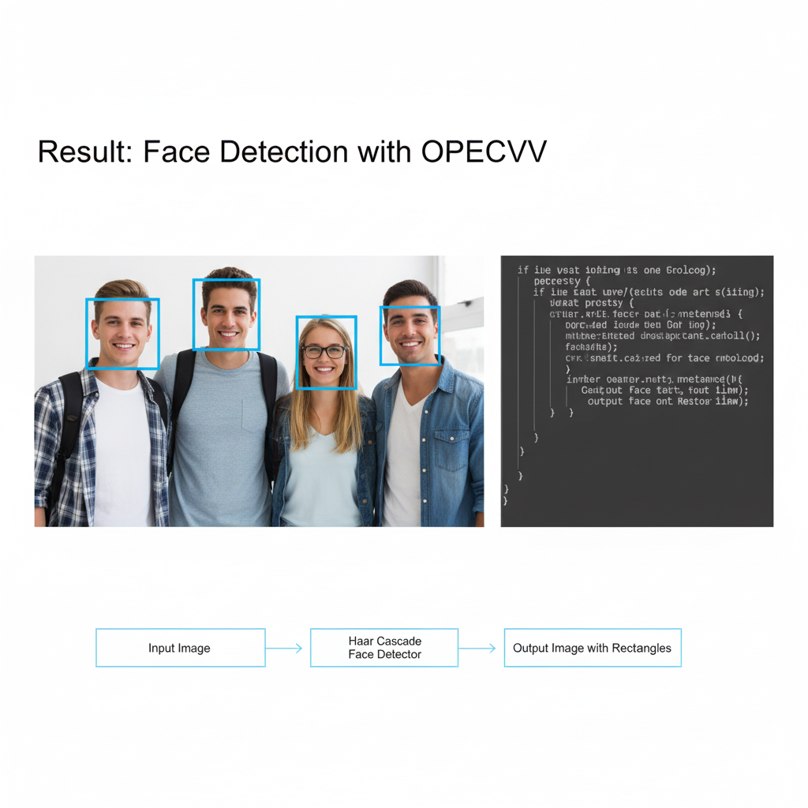
Face Recognition would follow, extracting features from these detected faces (e.g., using deep learning embeddings) and comparing them to a database of known faces using similarity metrics.
- Mass Storage:
  - Role: The system requires mass storage (e.g., hard drives, SSDs) for:
    - Storing the database of registered student images and their corresponding facial embeddings (features).
    - Archiving historical attendance records.
    - Temporarily storing captured images or video frames.
  - Coding Perspective: This involves database operations (e.g., using SQLite, MySQL, or NoSQL databases) to store student IDs, names, and their computed facial feature vectors.

# Conceptual Python snippet for storing a student's facial embedding
import numpy as np

student_id = "S001"
student_name = "Alice Smith"
# Assume 'face_embedding' is a numpy array representing extracted features
face_embedding = np.random.rand(128) # Example: a 128-dim embedding

# In a real system, this would be stored in a database
student_database = {
"S001": {"name": student_name, "embedding": face_embedding.tolist()}
}
print(f"Stored {student_name} with embedding in database.")
- Output Module:
- Role: The digital dashboard or user interface accessed by faculty serves as the primary output module. It displays real-time attendance, historical records, and reports.
- Coding Perspective: This often involves web frameworks (e.g., Flask, Django) or desktop GUI libraries (e.g., Tkinter, PyQt) to create interactive dashboards.
# Conceptual Python snippet for updating attendance and displaying
attendance_records = {} # {student_id: True/False}

def mark_attendance(student_id, student_name):
attendance_records[student_id] = True
print(f"Attendance marked for {student_name} (ID: {student_id})")
# In a real system, this would update a database and a GUI

# Example: after recognizing student S001
# mark_attendance("S001", "Alice Smith")
- Network:
- Role: The system often leverages a network (LAN or internet) to communicate between the camera, processing unit, database, and the faculty's access terminals.
- Coding Perspective: Network communication is handled by underlying protocols and libraries when interacting with remote databases or serving web dashboards.

Conclusion / Learning Outcome
This case study on an Automatic Attendance System using Face Detection, enhanced with coding examples, clearly illustrates the interplay of various components within a Digital Image Processing system. By dissecting this real-world application, we can effectively identify and understand the critical role of each system element:
- The image acquisition sensor (camera) is vital for converting the physical world into digital data, as shown by cv2.VideoCapture.
- The image processing unit (CPU/GPU) provides the computational power necessary for running algorithms efficiently.
- The software/algorithms perform the intelligent tasks of face detection (cv2.CascadeClassifier) and recognition, which are at the core of the system's functionality.
- Mass storage is indispensable for data persistence and retrieval, managing student profiles and attendance records.
- The output module ensures the processed information is actionable and user-friendly through interfaces.
- The network enables distributed operations and remote access.
Understanding this architecture and data flow, coupled with practical coding insights, provides a foundational understanding of how image processing systems are designed and implemented. It highlights that the successful deployment of such a system relies not just on advanced algorithms but also on the seamless integration and optimal performance of all its constituent hardware and software components. This knowledge is directly applicable to designing and analyzing various other computer vision and image processing applications, from medical imaging to autonomous vehicles.

